Power BI projects:
Activity 1
Creating an accessible report
Key insights:
Add a meaningful report title
Improve the accessibility of the chart visuals
Enhance accessibility of chart navigation by changing tab order

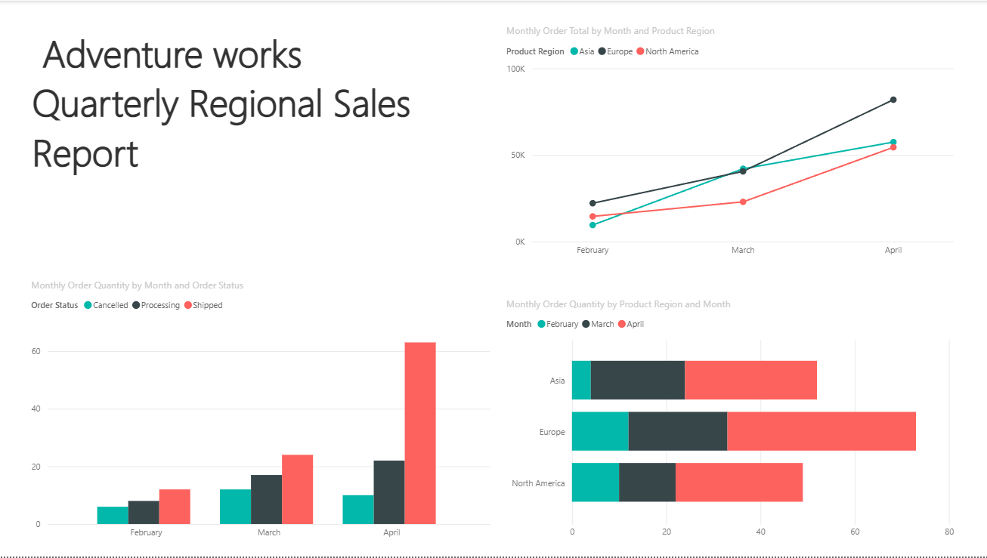

Activity 2: Creating an interactive report
Create the Sales Detail page
Connect the order Month as the Drillthrough field
Add a slicer for Product Category
Add a bookmark for Mountain Bikes sold in March
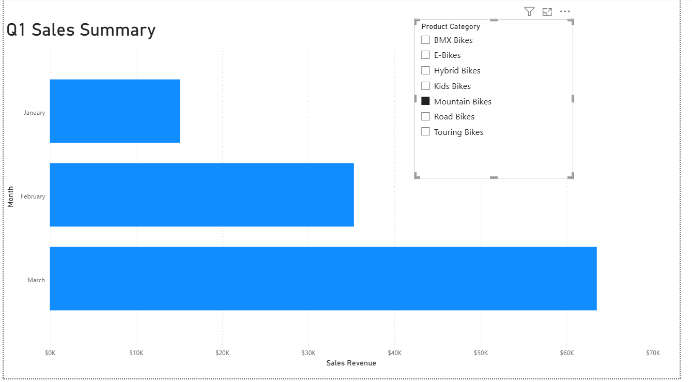
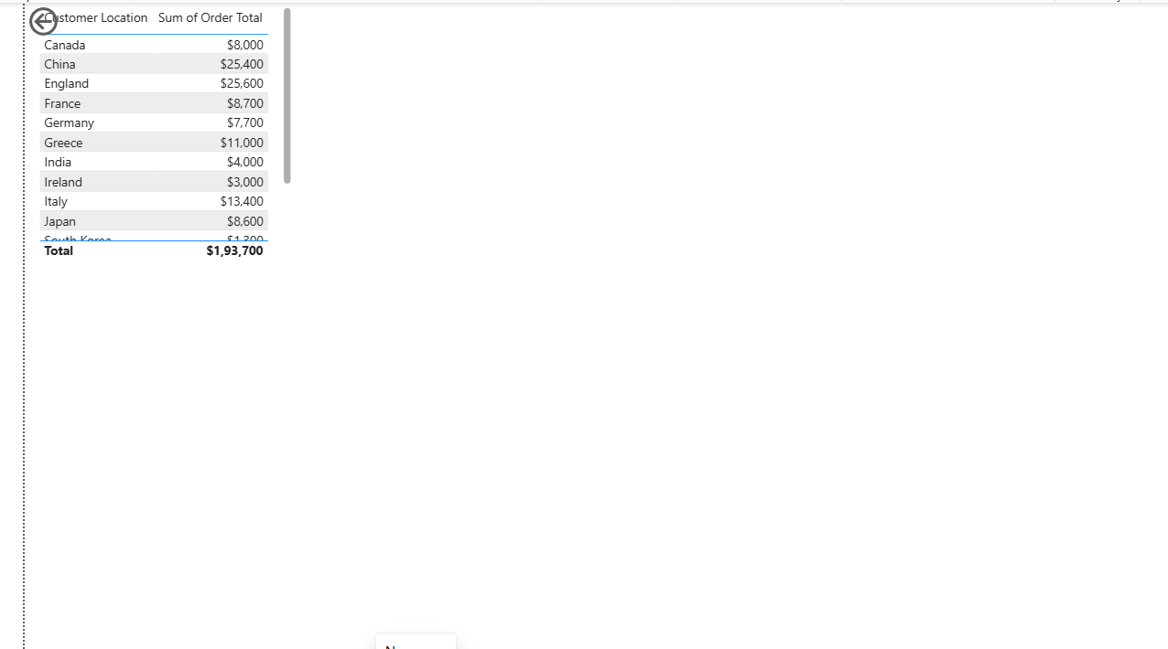

Activity 3:
Sorting and filtering a report
Key insights:
Sort the ribbon chart in chronological order
Apply filters so the ribbon and table charts display results for shipped orders only.
Sort the line chart by no of leads in ascending order.
Sort the table and stacked column chart by regions in ascending order.
Filter the stacked column and line charts to display leads from Facebook and Google only.
Display marketing data in the table for Facebook and Google only.
